**Assignment-1**

**Name: RAM PRASATH T.J**

**Team ID:**PNT2022TMID17431

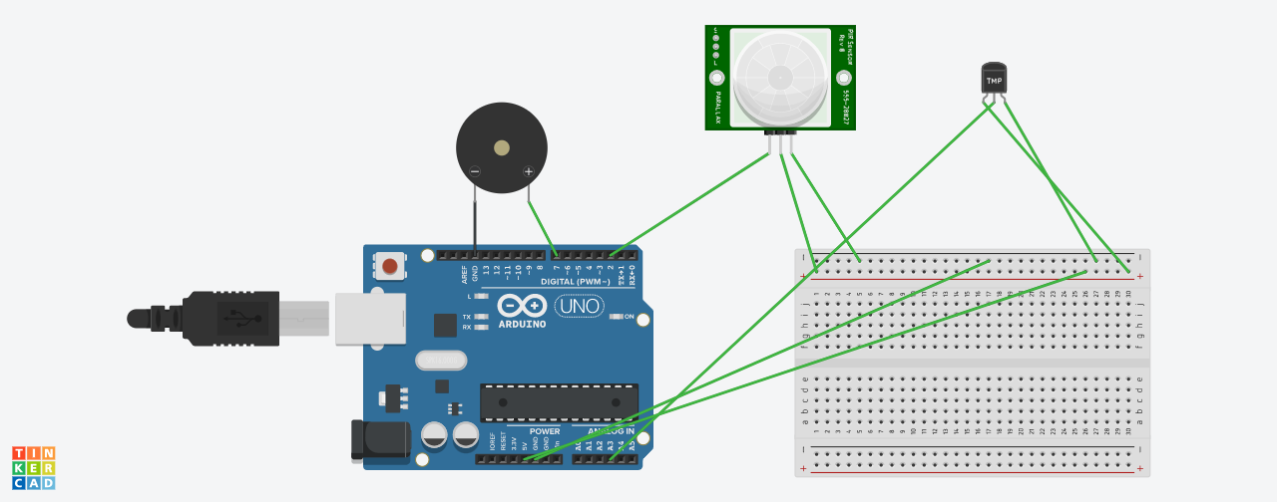

**CODE:**

int pinSensor =2;

int pinBuzzer =7;

int pirSensor =0;

float sensor=A3;

float analog;

float tempv;

float tempc;

float tempf;

void setup()

{

pinMode(pinSensor, INPUT);

pinMode(sensor, INPUT);

pinMode(pinBuzzer, OUTPUT);

Serial.begin(9600);

}

void loop()

{

analog=analogRead(sensor);

tempv=analog*5.0/1023;

tempc=(tempv-0.5)*100.0;

tempf=((tempc*9.0)/5.0)+32.0;

Serial.print("temperature:");

Serial.println(tempc);

if (tempc>=60)

{

tone(pinBuzzer, 200, 100);

}

delay(100);

pirSensor = digitalRead(pinSensor);

if (pirSensor == HIGH)

{

tone(pinBuzzer, 1000, 500);

}

delay(100);

}